Rohit Jagtap

Axon Classic Car Sales Analysis

Power BI Project Documentation



1. **Introduction of Project:**

* **Problem Statement:**

**A small company Axon, which is a retailer selling classic cars, is facing issues in managing and analyzing their sales data. The sales team is struggling to make sense of the data and they do not have a centralized system to manage and analyze the data. The management is unable to get accurate and up-to-date sales reports, which is affecting the decision-making process.**

**To address this issue, the company has decided to implement a Business Intelligence (BI) tool that can help them manage and analyze their sales data effectively. They have shortlisted Microsoft Power BI and SQL as the BI tools for this project.**

**The goal of the capstone project is to design and implement a BI solution using Power BI and SQL that can help the company manage and analyze their sales data effectively.**

* **Tools used in the capstone Project:**

**These tools and technologies can be used to extract, clean, and analyze sales data and build interactive dashboards and reports. They are widely used in the field of Business Intelligence (BI) and can be leveraged to solve a variety of data related problem**

* **SQL**
* **Microsoft Power BI**

1. **Importing SQL project Data into MySQL:**

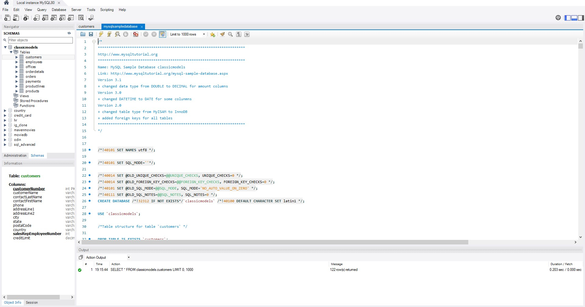

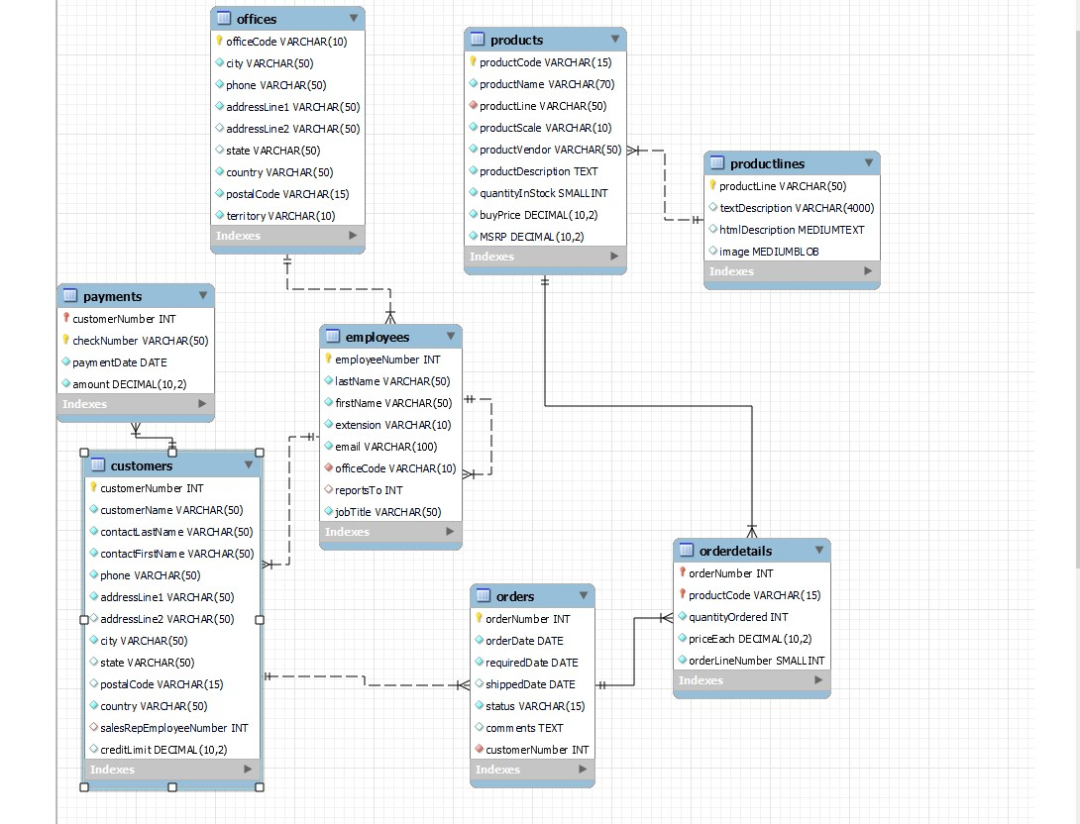

1. **Import the SQL file into MySQL workbench and create a database named ‘classicmodels’.**
2. **There are total 8 tables in the classicmodel databases.**
3. **Then connect the Power BI with MySQL databases.**

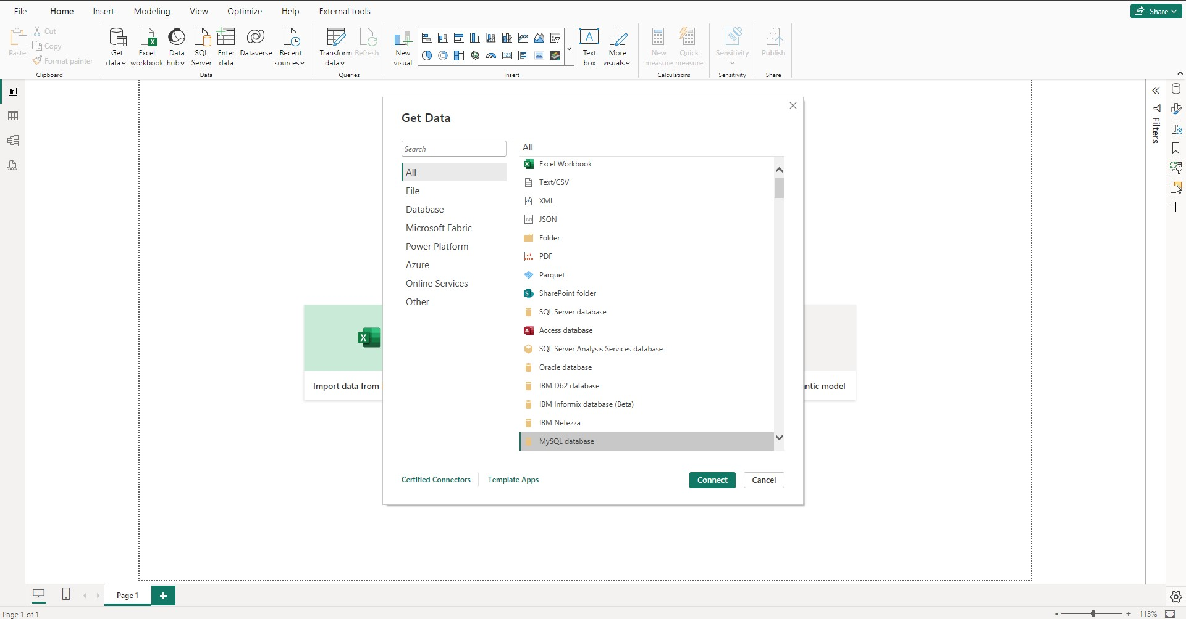

1. **Data transformation in Power Query Editor:**

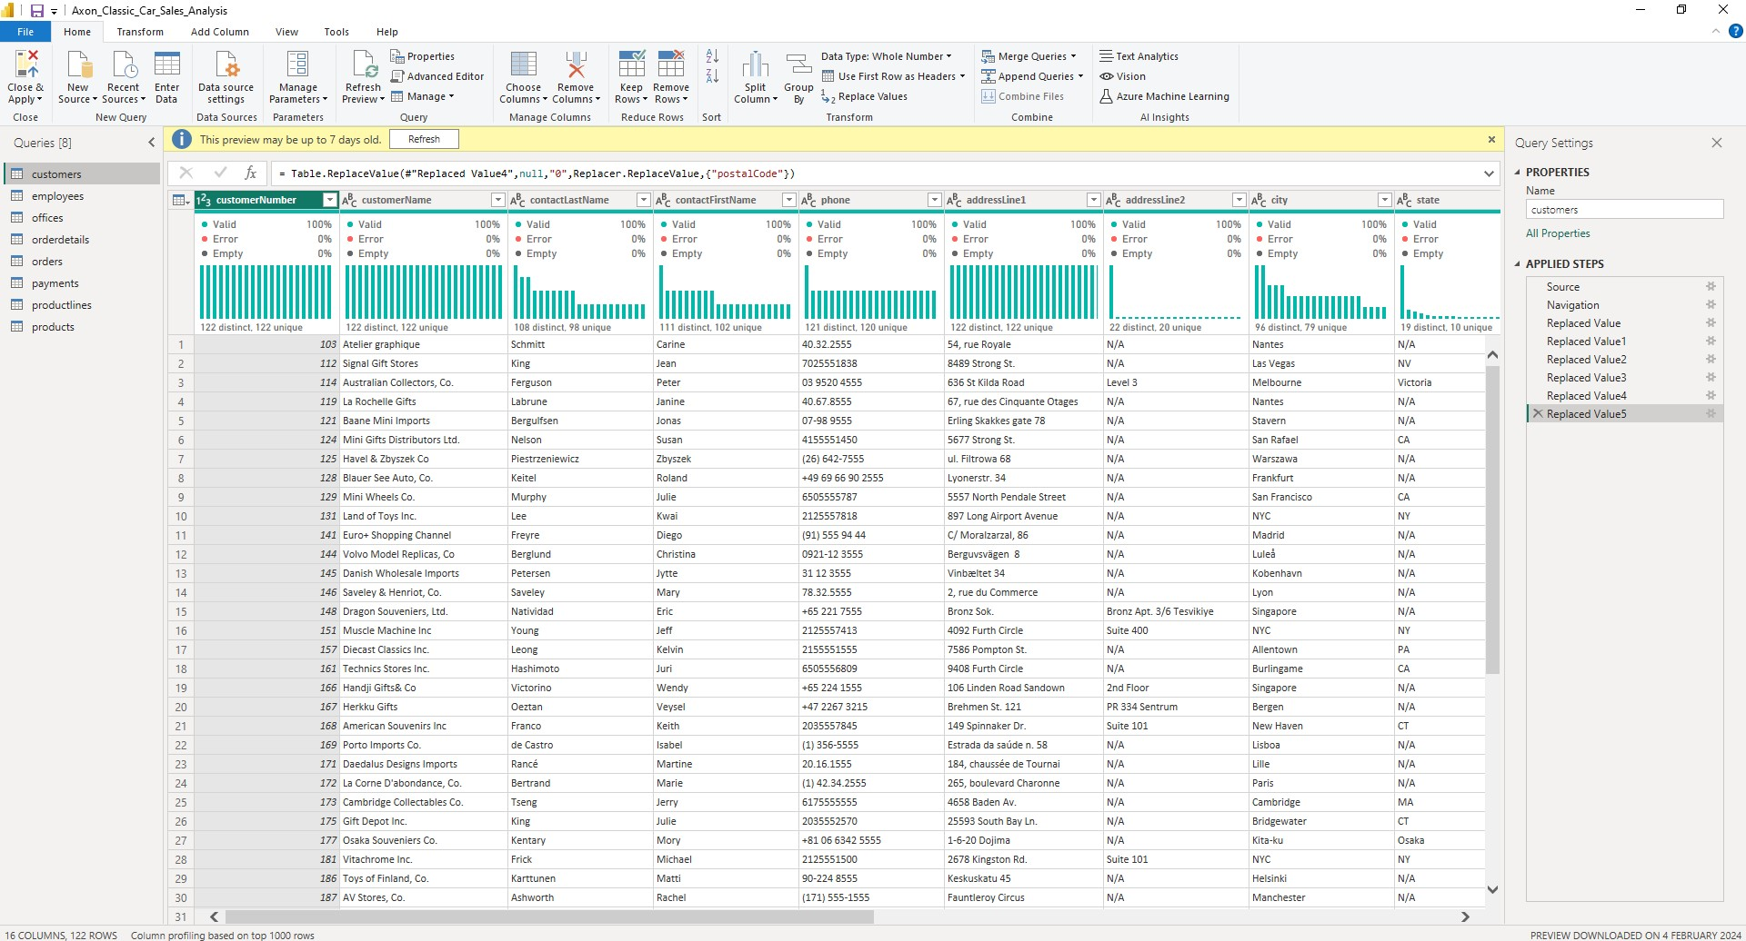

**Here are the steps followed in data cleaning and transformation:**

* **Transformation in Customers table:**

1. **Null values in the “addressLine2” column are being replaced with "N/A" (Not Available).**
2. **Any null entries in the “state” column are being substituted with "N/A".**
3. **The “PostalCode” column contains seven null values, which are being replaced with "0".**
4. **Null values in the “SalesRepEmployeeNumber” column are being replaced with "0"; there are a total of two null entries in this column.**

* **Transformation in employees table:**

**The null value in the “reportTo” column is being replaced with "0". This single null entry corresponds to the President, who does not report to anyone.**

* **Transformation in offices table:**

**The null values in the "addressLine2" column are being replaced with "N/A", as well as the three null values in the "state" column.**

* **Transformation in Orderdetails table:**

**No changes are required in this table; everything is in order.**

* **Transformation in Orders table:**

**The null values in the "comments" column are being replaced with "N/A".**

* **Transformation in payments table:**

**No changes are required in this table; everything is in order.**

* **Transformation in productLines table:**

**The "htmlDescription" and "image" columns are being removed from the dataset as they are completely null and do not contribute to our analysis.**

* **Transformation in products table:**

Top of Form

**No changes are required in this table; everything is in order.**

**Close and Apply changes in power query editor.**

1. **Leveraging the DAX to create New measure and column in Power BI Desktop:**
2. **“Customers” table:**

* Average Credit Limit by Country - New Measure:

Average Credit Limit by Country = AVERAGEX(VALUES('Customers'[country]), CALCULATE(AVERAGE('Customers'[creditLimit])))

* Average Credit Limit by Customers - New Measure:

Average Credit Limit by Customers = AVERAGEX(VALUES('customers'[customerNumber]), CALCULATE(AVERAGE('Customers'[creditLimit])))

* Customer Segment by Credit Limit - New Column: Creating new columns called “Customer Segment” based on creditLimit.

Customer Segment by Credit Limit = IF (customers[creditLimit]<=10000,"Low Credit",

IF (customers[creditLimit] <= 67660, "Medium Credit", "High Credit"))

-- Average credit limit is 67660

* Total Customers - New Measure:

Total Customers = DISTINCTCOUNT(customers[customerNumber])

1. **“employees” table:**

* EmployeeName – New Column: Creating new column “EmployeeName” using first name and last name of employee.

EmployeeName = employees[firstName] & " " & employees[lastName]

* Total Employees – New Measure:  
    
  Total Employees = DISTINCTCOUNT(employees[employeeNumber])

1. **“orderdetails” table:**

* SellingPrice – New Column:

SellingPrice = (orderdetails[quantityOrdered])*(orderdetails[priceEach])

* Total Quantity Ordered – New Measure:

Total Quantity Ordered = SUM(orderdetails[quantityOrdered])

* Total Selling Price – New Measure:

Total Selling Price = SUM(orderdetails[SellingPrice])

1. **“orders” table:**

* AvgDeliveryDays – New Measure:

AvgDeliveryDays = DATEDIFF(orders[orderDate],orders[shippedDate],DAY)

* Month – New Column:

Month = MONTH('orders'[orderNumber])

* Quarter – New Column:

Quarter = QUARTER('orders'[orderDate])

* Weekday Name – New Column:

Weekday Name = FORMAT(orders[orderDate],"dddd")

* Year – New Column:

Year = YEAR('orders'[orderDate])

* MTD – New Measure:

MTD = TOTALMTD(orderdetails[Total Selling Price],orders[orderDate])

* QTD – New Measure:

QTD = TOTALQTD(orderdetails[Total Selling Price],orders[orderDate])

* YTD – New Measure:

YTD = TOTALYTD(orderdetails[Total Selling Price],orders[orderDate])

* Total Cancelled Order – New Measure:

Total Cancelled Order = CALCULATE(COUNT(orderdetails[quantityOrdered]),orders[status]="cancelled")

* Total Orders – New Measure:

Total Orders = COUNT(orders[orderNumber])

1. **“payments” table:**

* Total Paid Amount – New Measure:

Total Paid Amount = SUM(payments[amount])

1. **“products” table:**

* Profit – New Measure:

Profit = [Total Selling Price] - [Total Cost Price]

* Total buyPrice – New Measure:

Total buyPrice = SUM(products[buyPrice])

* Total Cost Price – New Measure:

Total Cost Price = SUMX(orderdetails, orderdetails[quantityordered] RELATED(products[buyprice]))

* Total Margin – New Measure:

Total Margin = DIVIDE([Total MRP]-[Total buyPrice],[Total MRP],0)

* Total MRP – New Measure:

Total MRP = SUM(products[MSRP])

* Total Products – New Measure:

Total Products = COUNT(products[productCode])

1. **Data Visualization:**

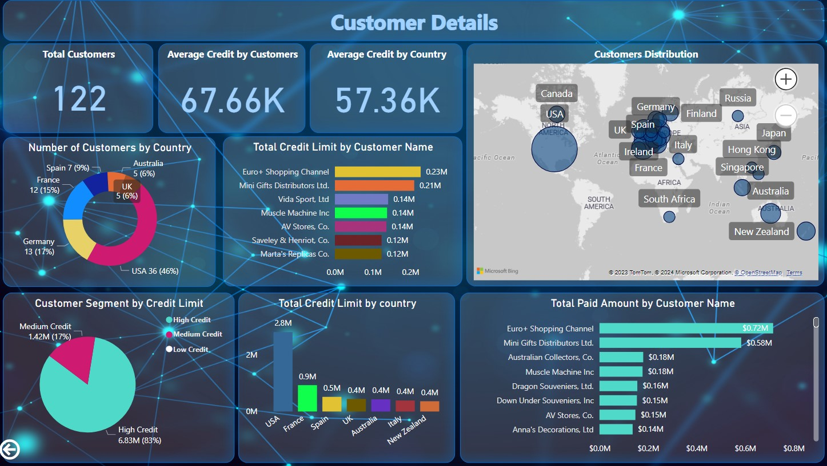

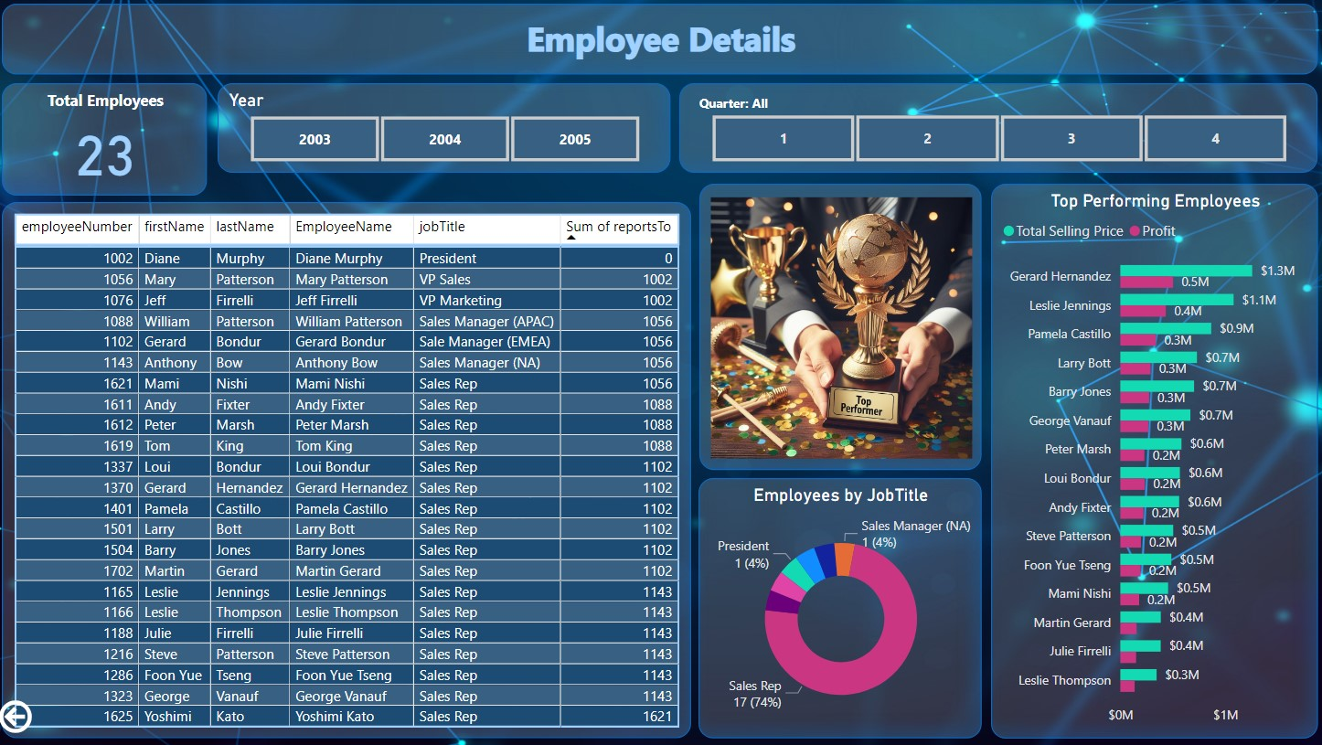

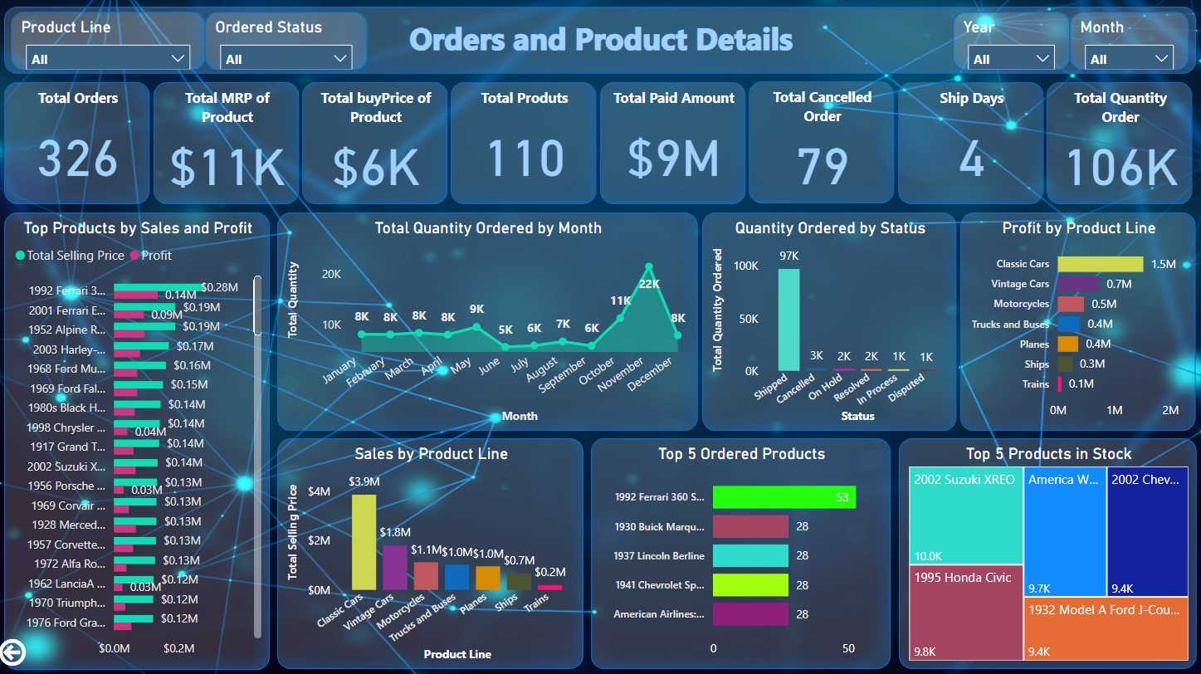

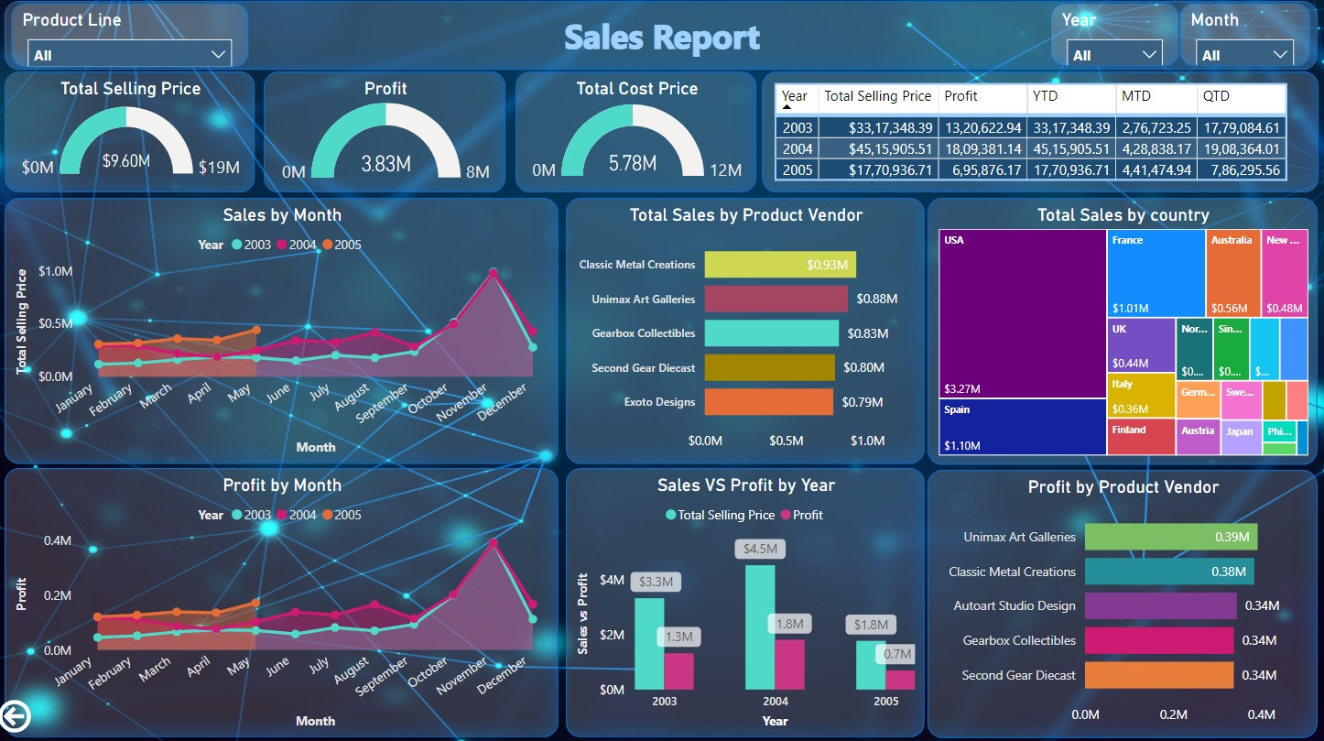

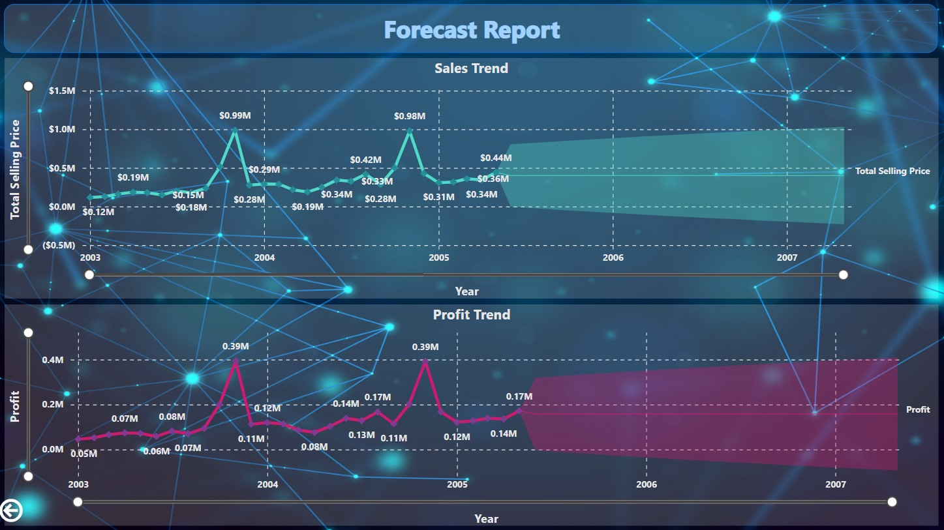

1. **Key Insights:**
2. Classic Cars is making $3.9 million in sales and $1.5 million in profit, and it's followed by Vintage Cars, Motorcycles, Trucks and buses.
3. The sales and profit for the year 2004 are at their highest, reaching $4.5 million and $1.8 million respectively, compared to the years 2003 and 2005.
4. In November, it looks like the highest amount of items were ordered. So, we might expect or predict the same for the year 2005.
5. The top vendors making the most profit from their products are Unimax Art Galleries and Classic Metal Creations.
6. The top three products are the 1992 Ferrari 360 Spider in red, the 1930 Buick Marquette Phaeton, and the 1937 Lincoln Berline.
7. The top three products currently in stock are the 1992 Suzuki XREO, the 1995 Honda Civic, and the America West Airlines B757-200.
8. The top three performing employees are Gerard Hernandez, Leslie Jennings, and Pamela Castillo.
9. The United States is ahead in sales, followed by Spain, France, Australia, and New Zealand, so focusing on these countries could lead to increased more business opportunities and helps to increase the growth of car sales.